Laboratory Exercise 6

Create a bare-metal “Hello World” application and run it on a debug configuration for a Cortex-A9 Fixed Virtual Platform (FVP) provided with ARM Development Studio.

Installation

- Install SoC EDS
- Install ARM DS
- Install Cygwin
- Install MingGW
- Install Linaro Bare Metal Toolchain

Please refer the attached file.

- Section 2 – Installing tools on Windows
- Section 3 and 4 – Running the tools and activating the license

Note: The SoC EDS Standard Edition is supported with the Intel Quartus Prime Lite/Standard Edition software and the SoC EDS Pro Edition is supported with the Intel Quartus Prime Pro Edition software.

Follow the steps to create a new C project:

1.
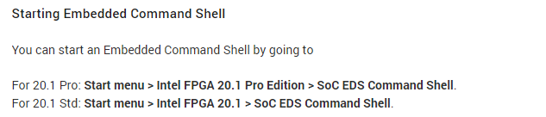

2.
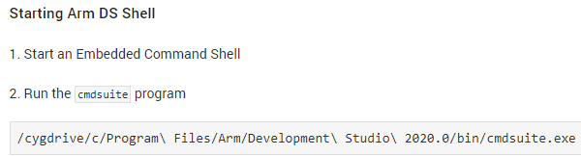

3.
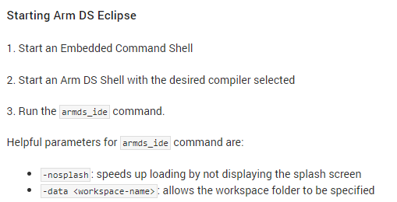

4. Refer the below attached document

